Trademark Landing Page Audit

Fix This First
- The landing page is branded "LegalAegis" — not Edwin Corporate Law Firm. Wrong name, phone, email, address, and disclaimer appear throughout (header, hero form, footer).
- It also shows unverified claims ("150+ In-House IP Attorneys," "ISO 9001:2015 Certified") not found on the core site.

Pricing
Source | Basic | Premium | Gold
Core website | Rs 8,999 (bundled) | Rs 15,999 | Rs 19,999
Current landing page | Rs 1,499 + govt fee | Rs 2,999 + govt fee | Rs 4,999 + govt fee
Client-supplied — FINAL | Rs 3,999 | Rs 6,999 | Rs 11,999

Brand identity — partially fixed, still incomplete
Client-supplied content gives us real, verifiable replacements for two of the fake "LegalAegis" elements:
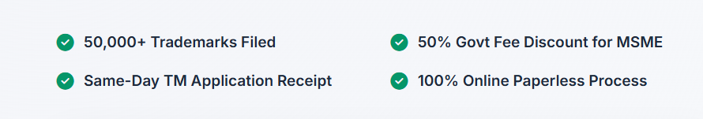
- ✅ Founder bio (Adv. Ajay Verma) — can replace generic/absent founder content
- ✅ Real stat: "5000+ Brands & Logo Successfully Applied" — replaces the unverified "50,000+ Trademarks Filed" claim
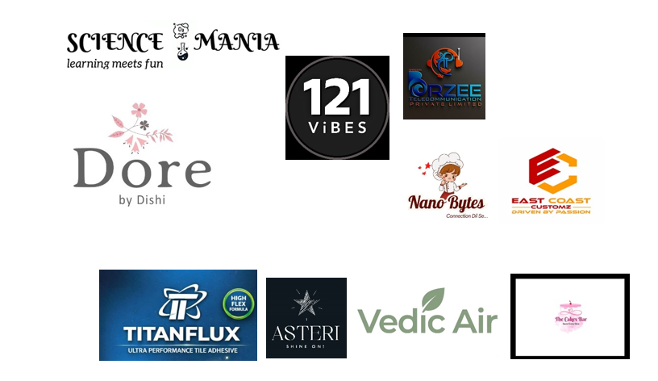
- ✅ Client/brand logos — real social proof, can replace generic trust badges

Verify the below shown data in the landing page
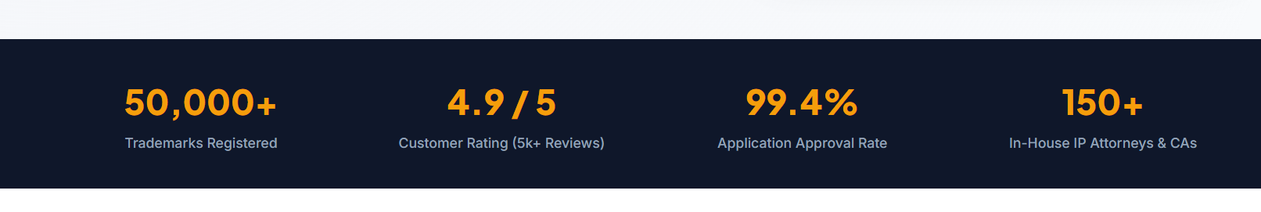

Still missing some sections at footer
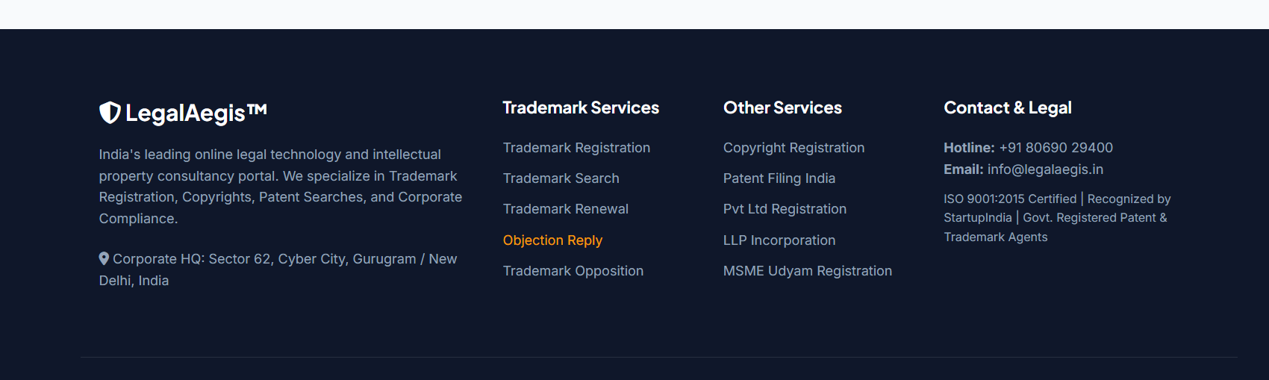
actual phone number, email, office address, and legal disclaimer text for Edwin Corporate Law Firm. The client file doesn't include these — request them separately. Until they're in hand, the page still can't go live.
Do add this too at footer

New Content to Add
- "Meet the Founder" section — use Adv. Ajay Verma's bio as supplied. Good trust-builder, currently missing from the page entirely.
(Adv. Ajay Verma
Founder
With over a decade of experience, Ajay, the Founder of Edwin Corporate Law Firm, has been the driving force behind the firm’s vision and growth since its inception. Ajay is recognized for his pragmatic approach to IP advisory, trademark portfolio management, and strategic patent enforcement.
His leadership at Edwin Corporate Law Firm is defined by a commitment to delivering precise, forward-thinking legal solutions that safeguard the intellectual capital of both emerging startups and established corporations. He has dedicated his practice to helping businesses navigate the complexities of protecting their core innovations, brand identities, and creative assets.)
- Client/brand logo strip — 10+ logos supplied but unlabeled (image files only, no company names attached). Action: confirm with client which brands these are and get permission to display them before publishing.
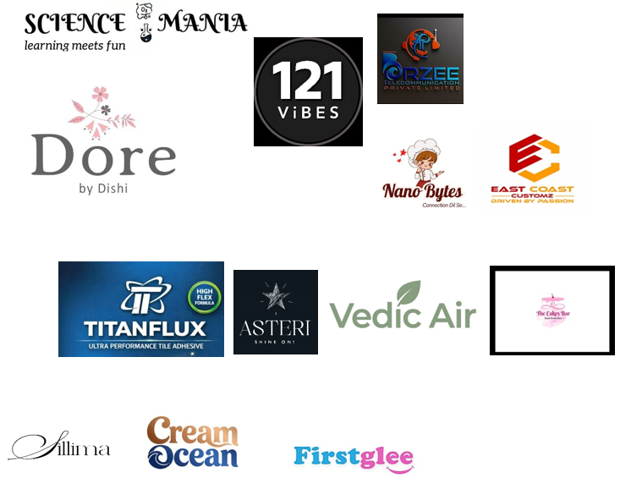
- Updated trust stat — swap "50,000+ Trademarks Filed" for the client's real number, "5000+ Brands & Logo Successfully Applied." Smaller number, but it's accurate — more defensible than an unverifiable claim.
- Use this description “Protect your Brand Name, Slogan & Logo from copycats — with expert legal support from filing to registration.”
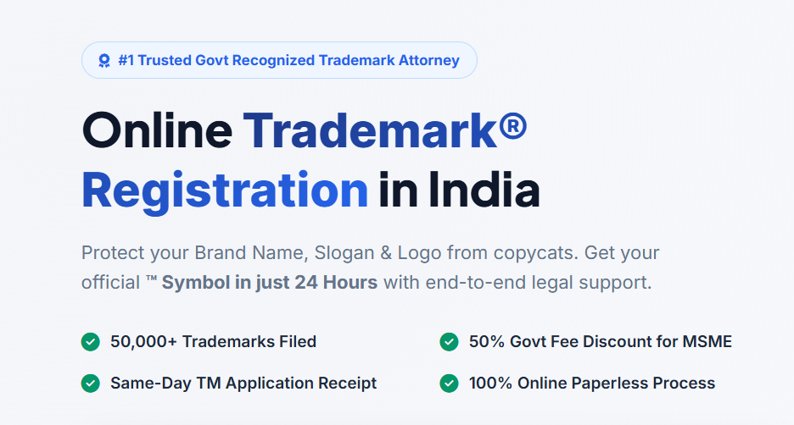

Other Findings (unchanged from original audit)
Topic | Issue | Fix
® symbol timeline | Core site claims "6 months" — likely false | Remove or replace with an honest range
TM symbol timing | "TM Symbol in just 24 Hours" could read as legal approval | Clarify it's the filing receipt only
Core site grammar | Several unclear/incorrect sentences | Flag to core site copy owner

UI/UX
- Pricing toggle (Individual/MSME vs. Corporate) is too subtle—re-check
- contrast/visibility once the Basic/Premium/Gold prices are updated
- Legal disclaimer text is tiny/low-contrast
- Nav CTA and hero form duplicate the same action
- Trust stats repeat twice (checkmark row + stats bar) — now also needs updating with the new "5000+" figure
- Class search bar needs example chips
- Repeated "Govt Fee" line across all 3 pricing cards
- Floating WhatsApp/call buttons need labels or spacing
- Benefit icons all use the same generic style (low priority)

Updated Priority Checklist
🔴 Before launch
- Update pricing on both pages to the client's final figures — Basic Rs 3,999 / Premium Rs 6,999 / Gold Rs 11,999 — and rename tiers to match (Basic, Premium, Gold)
- Get real phone/email/address/disclaimer for Edwin Corporate Law Firm from the client
- Get logo permissions/names confirmed before publishing the client logo strip
🟠 Before heavy traffic
4. Add the Founder section and updated trust stat
5. Make the pricing toggle obvious (re-verify after Basic/Premium/Gold prices go live)
6. Increase visibility of the legal disclaimer
7. Fix the core site's "6 months" claim
8. Drop or verify the "150+ Attorneys" claim
🟡 When time allows
9. Resolve duplicate CTA and duplicate stats
10. Add example chips to class search bar
11. De-duplicate the "Govt Fee" line
12. Space out/label floating buttons
13. Update CTA copy per suggestions above

